Store1 Restoration Utility Instructions

# How to search and restore a file/folder

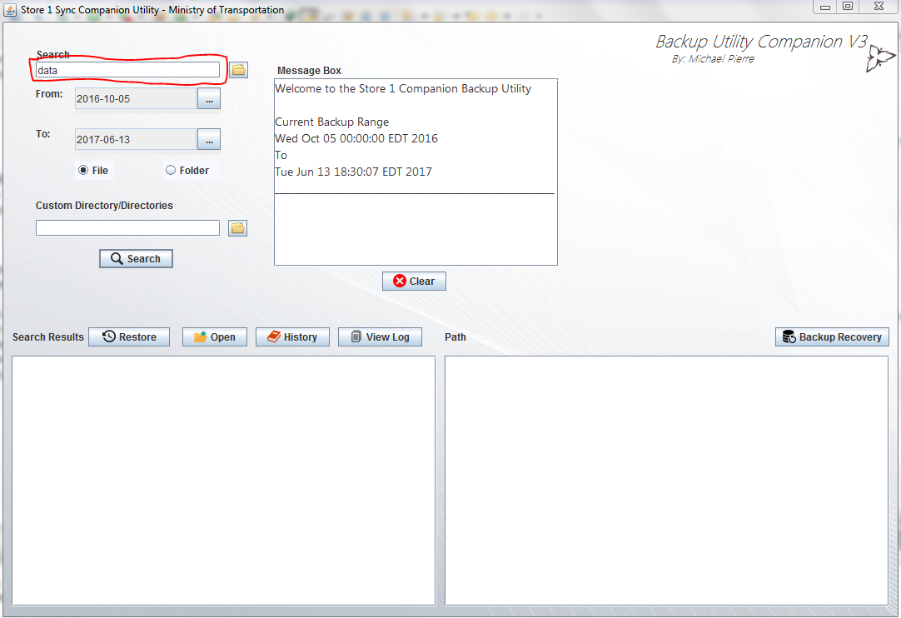

Figure 1, initial start of the application

**Step 1:** Locate the search bar at the top left of the screen and type in the file or folder you wish to search. If you don’t know the full folder name you can search the first few letters or the first word and the application will match relevant results.

As seen in figure 2 if you know the exact file you wish to search for you can click the folder icon beside the search bar and select the file using the included file explorer window

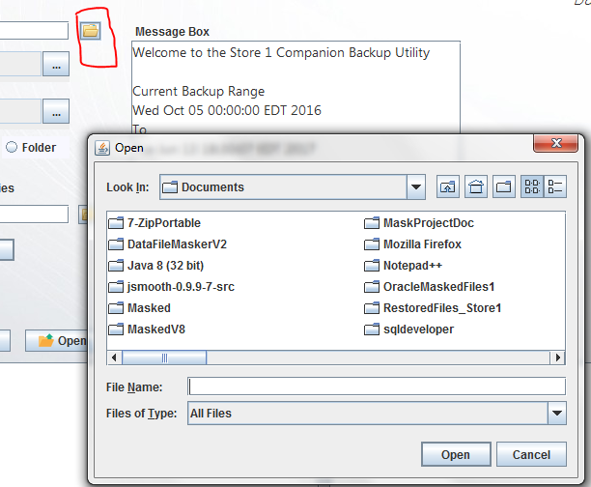

Figure 2, search for specific file

**Step 2:** Once you have entered your search word or exact file name you have the option to choose the date range you wish to search in. Note that large date ranges will affect the speed of the search as well as the system specifications.

By clicking the button with the three dots a graphical calendar view will open for easier date selection

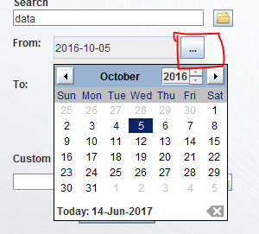

Figure 3, choosing dates

**Step 3:** Once the date range is selected there are two options available. File and folder radio button essentially specifies if you’re looking for a file or folder.

Below the file and folder radio buttons you also have the option to search a single directory or multiple directories. To choose multiple directories click the folder icon beside the search bar and use Ctrl plus left mouse click to select multiple backup folders

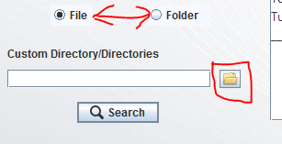

Figure 4, file and folder selection and choosing custom directories

**Step 4:** With all the appropriate information entered, press the search button to begin the search process (the enter key on the keyboard also searches). When the process is done the results will display at the bottom of the screen. The left side shows the file or folder names found and the right side shows each results path or directory.

Double clicking of the result will open its parent folder while clicking “open” button will open the path seen on the right side of the screen (meaning for files clicking open will actually open the file if it has a default program to open with like excel or word).

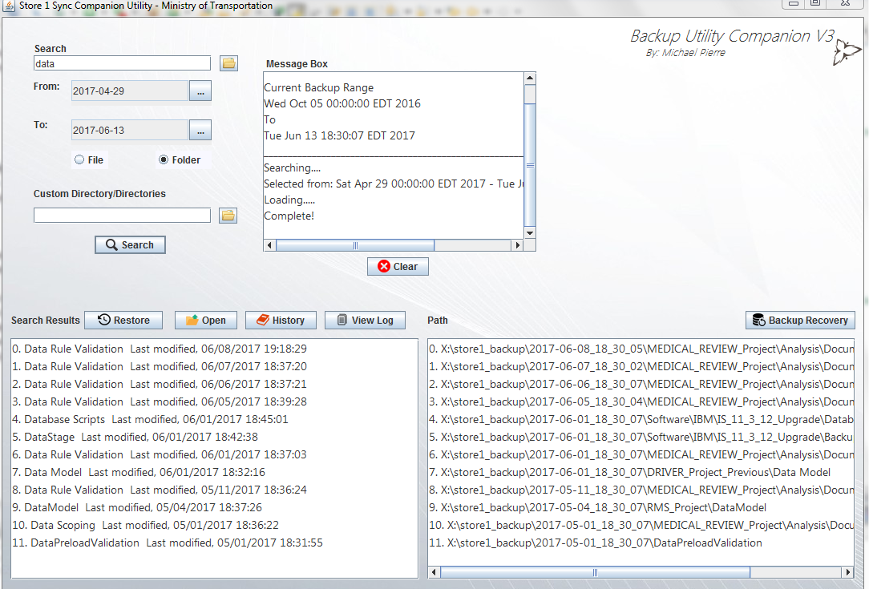

Figure 5, search results

**Step 5:** To restore a file or folder in the result list click the result you wish to restore and then click the restore button located above the search result list. This will open a file explorer window which default location is a restoration folder in “My Documents.” Once you have found you’re desired save location click save and the file will be restored. Once restored the folder containing the file or folder will be opened.

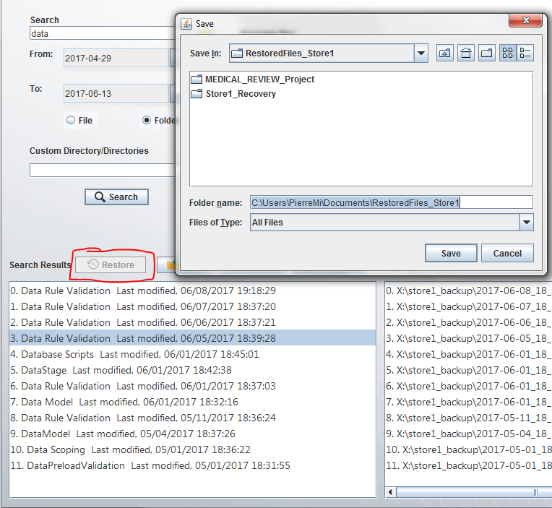

Figure 6, restoring a folder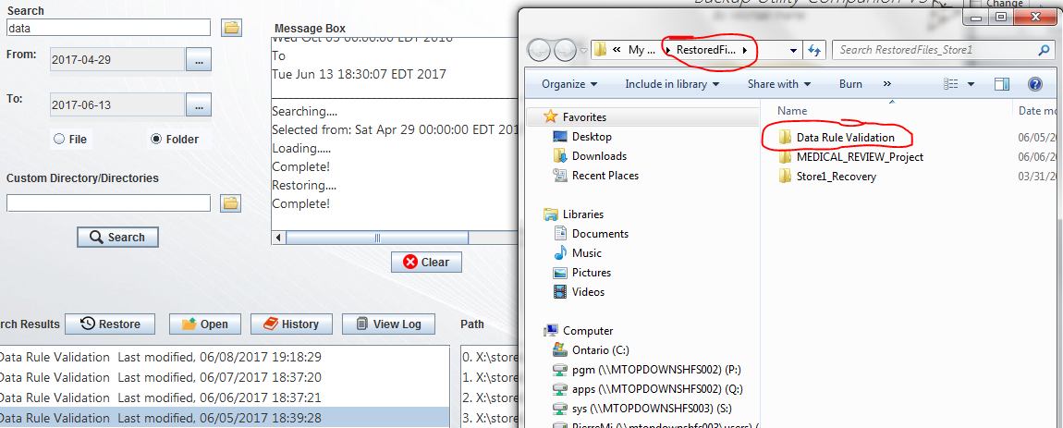

Figure 7, restored folder location opens

# How to view specific file or folder history

To view specific file or folder history click the history button above the search result list with a file or folder highlighted.

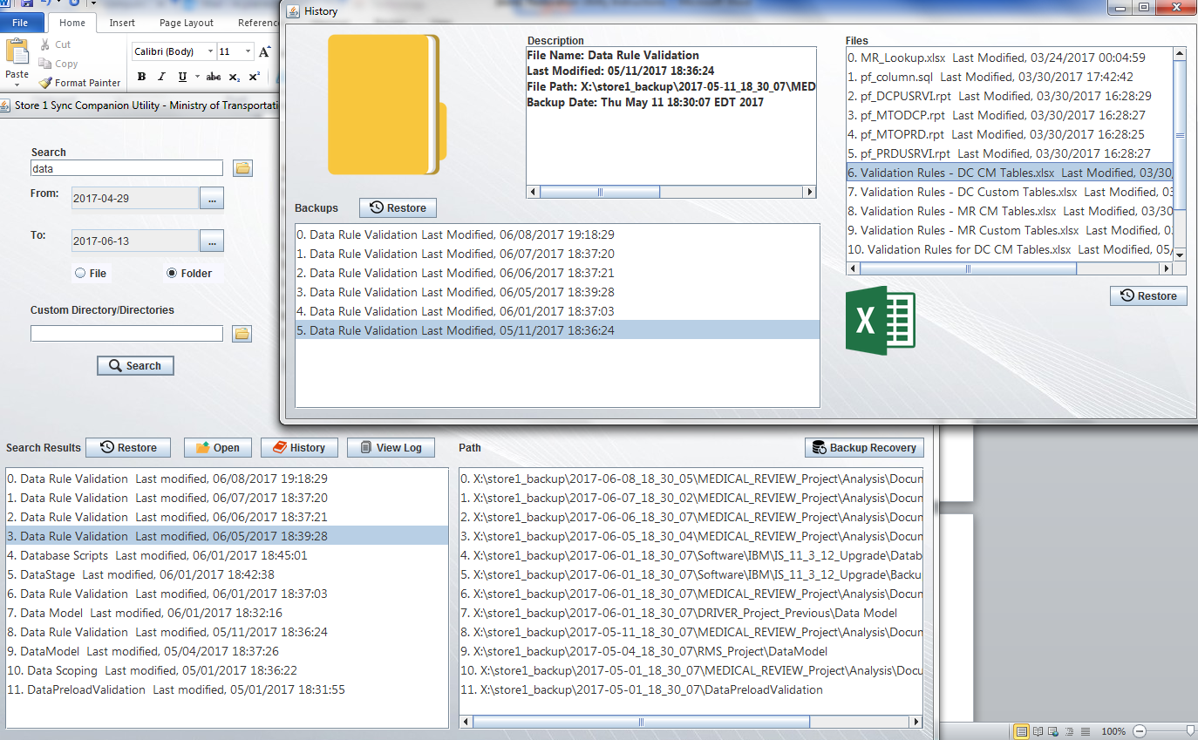

Figure 8, viewing folder history

In the history view you can track what has changed to that specific file or folder over the course of the backup in your defined date range. The right side shows all the files contained in the folder and the left list shows the folder and its different backup dates.

The restore functionality works the same as in the “How to search and restore a file/folder” instructions. Note: Make sure the desired folder or file to restore is highlighted and click the restore button. In this case the left restore button is to restore the folder and the right restore button is to restore the file in the folder.

# How to perform a backup recovery

**Step 1:** Click the back recovery button located on the right side of screen.

C:\Users\PierreMi\Pictures\restoreStep9.PNG

Figure 9, backup recover button

**Step 2:** A backup recovery window will open with “From” and “Two” date ranges. Just like the “How to search and restore a file/folder” instructions these date pickers work the same way.

Note: Choosing a large recovery range could take several hours to complete and ultimately depends on the hard disk and system specification.

Once a reasonable date range is picked click the recover button. This will open up a file explorer window with the default location being a restoration folder in “My Documents.” Choose the desired location and click “Save.” The recovery will begin and once done will open the folder containing the backup recovery.

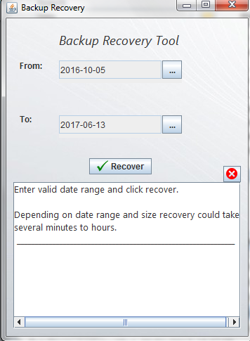

Figure 10, backup recovery window